The Dreampod V-Max
The largest pod on the market!

You asked for it and we listened. The result is the Dreampod V-Max. It’s the big brother to our best selling V2 and the largest pod on the market. It’s perfect for athletes, couple floats, or individuals wanting a bit more space.

The exterior of the V-Max is handcrafted using the highest quality fiberglass and plastics. Each one is polished to a high glossy finish ensuring a surface that’s not only aesthetically stunning, but easy to clean and maintain. There is a solid foam core embedded inside each pod. This maximizes soundproofing and heat retention. Which allows for a more comfortable float. It also cuts down on the electrical costs of owning a Dreampod.

Below are just a few features of the V-Max-

- An easy to use web based control panel for day to day operations

- A UV light integrated into the filtration system

- An accurate dual chemical dispenser for easy water maintenance

- A high efficiency in-line titanium heater

- Crystal clear underwater speakers built into the pod

- A 10 micron filter

- A soothing LED light inside the pod

- An anti-slip surface on the floor of the pod

- An “Auto Mode” that keeps the temperature at a preset level

Recommendations for room design and requirements for operations
Room design and setup is crucial in providing an ideal space for floating. You want the room to be welcoming and comfortable but also functional and easy to clean. We’ll cover some specifics needed for the Dreampod itself, as well as some best practices and recommendations.

First off, we designed the V-Max to break down into 3 different parts; the base, lid, and back piece. This makes moving it into place much easier. The base is the largest piece and measures 2624 mm. / 8ft. 6 in. long, 601 mm / 2 ft. tall, and 1771 mm / 5 ft. 8 in. wide.
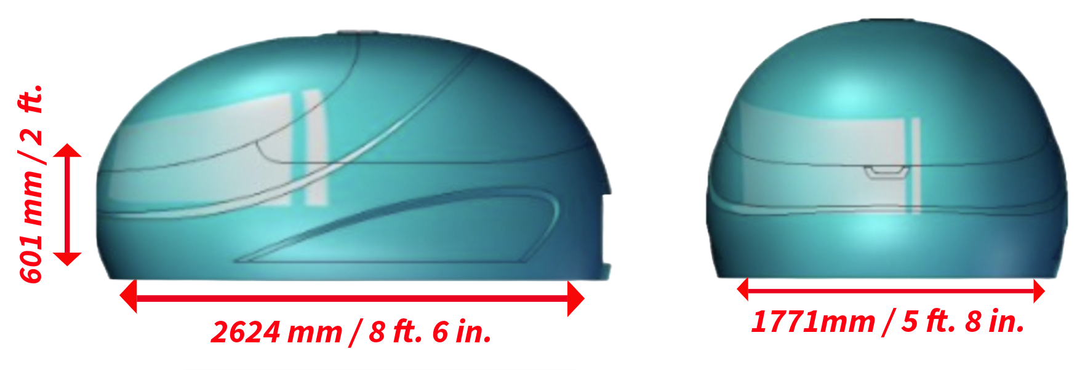
See more size dimensions on our website- https://www.dream-pod.com/the-dreampod-vmax/

In order to safely maneuver the base through hallways and around 90° corners you will need a minimum width of 1400 mm / 4 ½ ft. The base will also fit through any standard doorway.
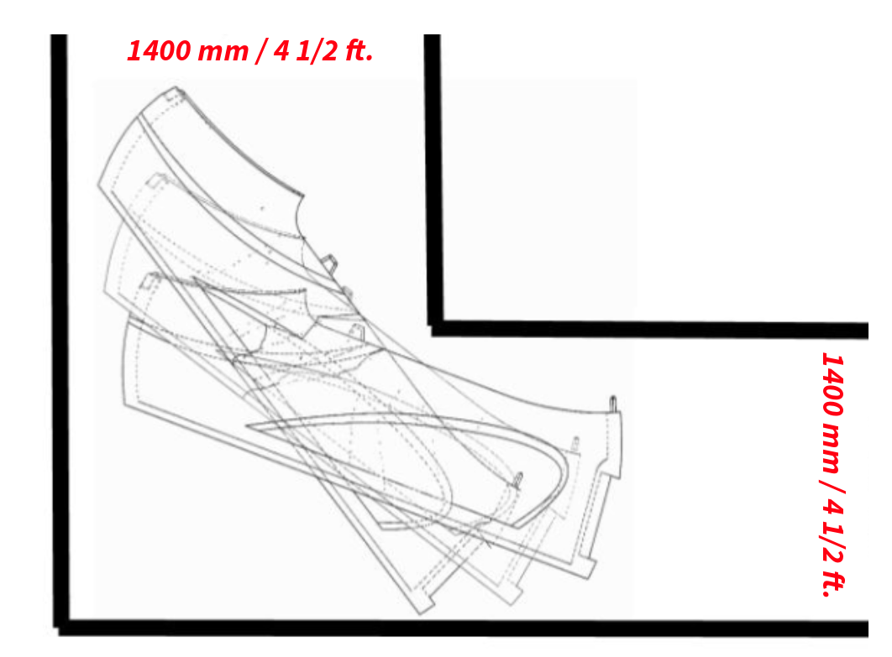
The minimum room size we recommend is 400 mm/10 ft. x 3000 mm/14 ft. and a ceiling height of at least 2200 mm/7 ft. This will allow enough space for the pod and engine box as well as enough clearance for the lid of the pod to open completely. We also recommend having a shower for clients in the room. This will be used before and after each float. Lastly, a small seating/changing area as well.

There will need to be a minimum of 800 mm/2 ft. clearance behind the pod. This will allow enough space for all the connections between the pod and engine box to be made.
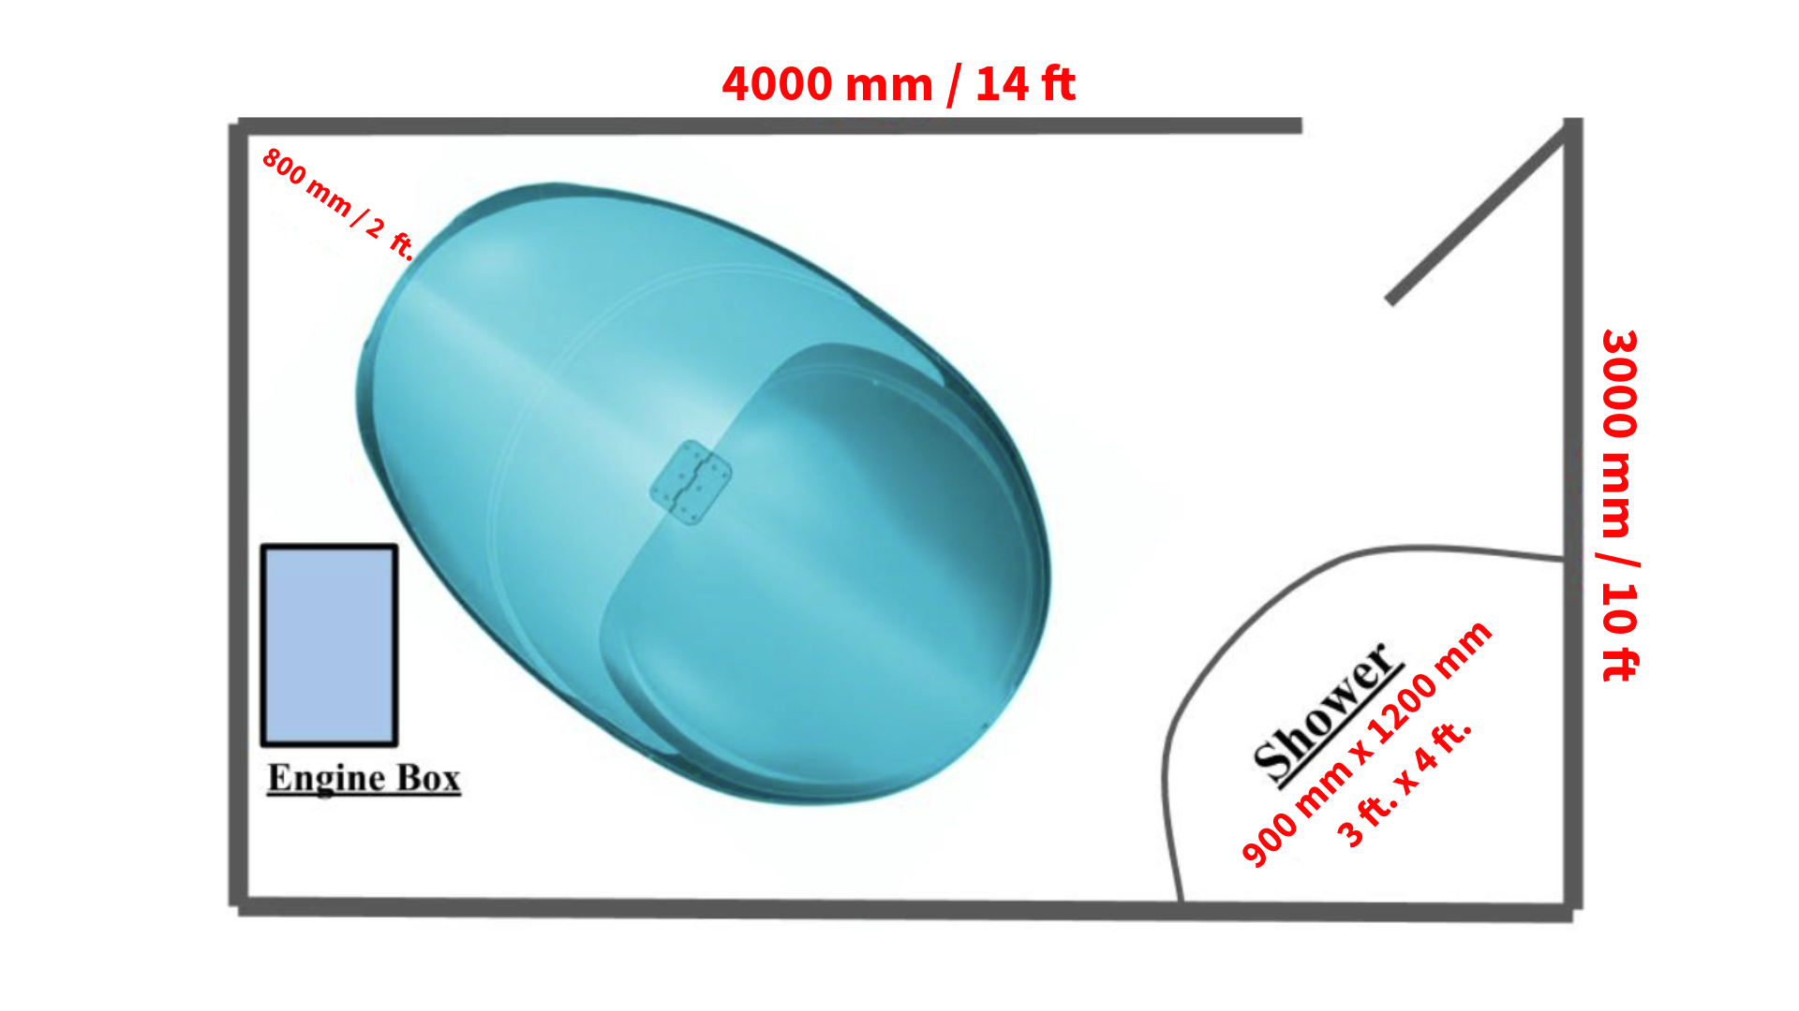
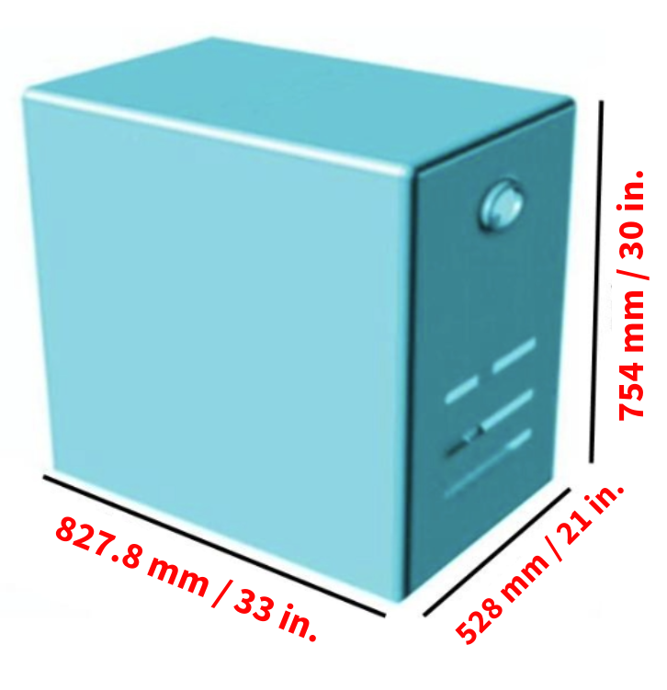 | The engine box will sit directly next to the pod and houses all the important components for filtration and operation of the pod.
These are two of the most important things needed for the pods operation.

- A single phase power outlet set up on it’s own individual GFCI breaker
- A dedicated CAT 5 port/jack connected to the main network router for the business

North America | Australia/New Zealand | Asia/Europe | East Japan | West Japan
220 Volt/60 hz  15 amps | 240 Volt/50 hz  15 amps | 220 Volt/50 hz  15 amps | 200 Volt/50 hz  15 amps | 200 Volt/60 hz  15 amps

Both of these are crucial to the successful and safe operation of the pod. The CAT 5 connection will be used to connect to the pods software. Ethernet over power lines, wireless bridges, or repeaters are not supported and will not work for the setup.

You will also need internet service up and running in order to set up the software. But, once it is set up you will be able to control the pod from any laptop, desktop, tablet, or mobile device. As long as it’s connected to the same network.

It’s important the room is prepared for the wet and salty environment the pod brings. Remember, there’s over 450 kg/1000 lbs. of Epsom salt inside the pod. It’s also important to ensure the room is as sound proof and light proof as possible.
Here are a few things we highly recommend, considering the harsh nature of the Epsom salt. Keep in mind, the more non-porous surfaces you have the better off you’ll be.

- Non-slip flooring
To ensure a safe and healthy environment a seamless non-slip vinyl or rubber floor covering is recommended. In the event tiles are used, take adequate steps to waterproof the sub flooring and use an epoxy grout.
- Walls and baseboards
Epoxy paint should be used when painting the room. Also, consider eliminating baseboards and instead having your flooring material continue up the wall a few inches. Lastly, we also recommend the use of fiberglass reinforced panels (FRP) in high traffic areas. Such as around the shower.

- Ventilation and room temperature
The room requires some form of a mechanical air circulation system. This will enable a supply of fresh air and remove stagnant air. Typically, a standard HVAC system will suffice and the addition of a standard bathroom exhaust fan is more than enough. If possible, it’s ideal to have control over the temperature of the room directly, rather than rely on the overall temperature control for the business. The ideal room temperature is anywhere between 26° to 28° C / 78° to 82° F.
- Lighting
Minimal soft lighting is ideal for the room when in use by the client. This will help create a relaxing calm environment. Inversely, bright lighting options are useful when cleaning the room.
- Floor drains
If possible, it is ideal to have a floor drain positioned between the shower and the pod. This will make cleaning between clients fast and easy. Another alternative would be to have an open shower design and utilize the drain in the shower.
- Water hook up
When it comes time to fill up the Dreampod with water this will be accomplished using a standard garden hose. Periodically, water will also need to be added to the pod. Because of this, we recommend having a dedicated water hook up inside the room. Otherwise, connecting to the nearest water source and having a hose long enough to reach the pod will be needed.
- Pod drainage
The Dreampod is a closed loop system and does not require any external plumbing or drainage to be connected to the pod or the engine box. The system circulates and heats the float solution via the engine box. In the event water needs to be drained, a submersible pump is used.
- Liability waiver and posted instructions
The proper “float position” is with your feet pointed towards the back wall of the pod. This is a crucial point of safety and should be expressed both verbally to every client, as well as outlined in a written liability waiver signed by each client. This should be mandatory prior to allowing the use of the float tank. We also recommend posting this, along with other instructions for your clients to follow, inside the actual room with the pod.

- Post float area
In order to ensure a quick turn around between clients it’s ideal to position the “post float area” away from the actual float room. This area will be where clients can freshen up after a float. Mirrors, blower dryers, and other essential items should be placed in this area and not in the float room.

As always, don’t hesitate to reach out to our team with questions any time. support@dream-pod.com

